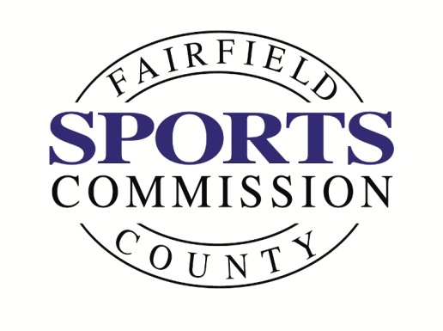
INVITES YOU TO THE FIRST “6 PM CLUB NIGHT”

Thursday, March 30, 2017
6-9 PM
“Sports Business Careers of the Future”
Panel Discussion featuring
- Dave Torromeo, Exec. Director, Sport Business Management Masters Program, Manhattanville College
- Mary Lobbestael, SVP at Octagon Marketing
- Terry Lefton, Editor-at-Large at Sports Business Journal,
Sports Business Daily
Cocktails, hors d’ourvres & social time with your peers!
PLEASE RSVP
rjmattmedia@gmail.com

Workpoint (use side entrance)
Shippan Landing, 290 Harbor Drive, Stamford

